Oracle NoSQL Database with ORM stack

Contents

1. Introduction 3
2. Workflow diagram to deploy the stack 3
3. Create stack for No SQL Database 4
4. Plan the Job 6
5. Apply the Job 7
6. Verify in the Console 8
7. Destroy the stack 9

Introduction

Oracle NoSQL Database in OCI is a distributed, highly available, and horizontally scalable NoSQL database service. It is designed to handle large volumes of data with low latency and high throughput. It offers key-value storage and allows developers to build applications that require fast and predictable performance.
Overall, Oracle NoSQL Database in OCI offers a scalable and highly available solution for storing and managing large volumes of data in a NoSQL format, making it suitable for various use cases, including web applications, IoT data storage, real-time analytics, and more.

Workflow diagram to deploy the stack

Below diagram shows how the Terraform Artifact are applied in the OCI. While creating a ORM stack, using terraform deliverables Init, Plan and Apply is the flow to provision the resource in the OCI. We can have the deliverables in any of below.

- GitLab/GitHub Repo
- Bitbucket
- Can be in folder/.zip in the local disk
- Object Storage Bucket
- Can be in compartment
- Oracle provided Template


Create stack for Oracle NoSQL Database

Go to OCI Console Developer Services Resource Manager Stacks select the compartment Create Stack

My Configuration Folder Browse Select the “nosql” folder that contains the terraform Upload

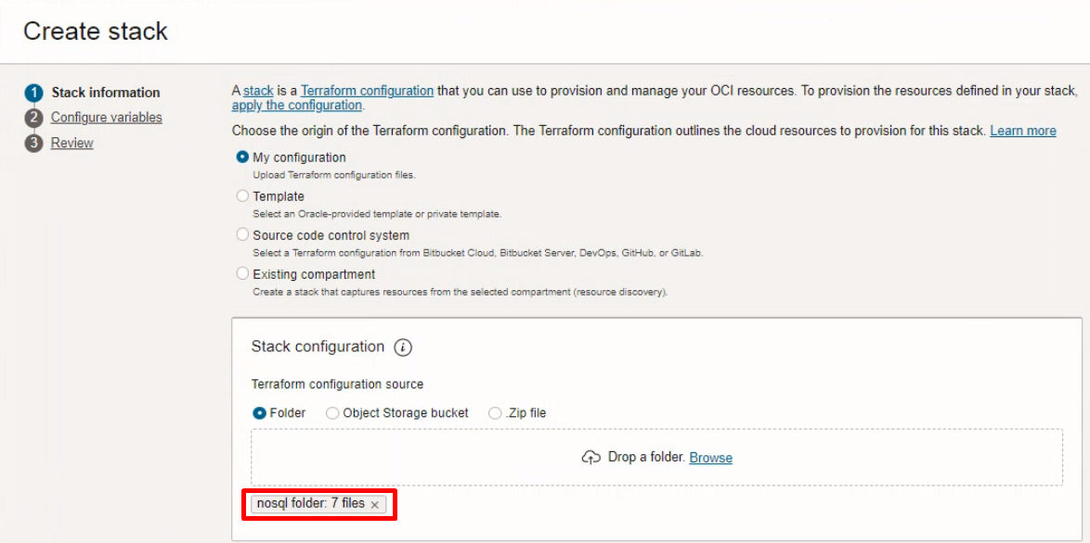

Select the parameters as per the below screen,

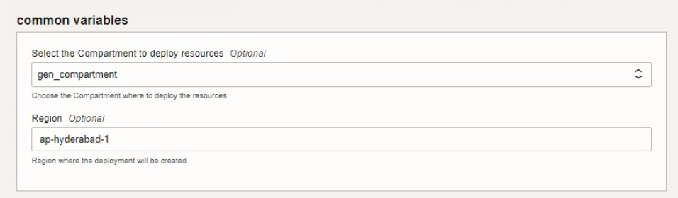

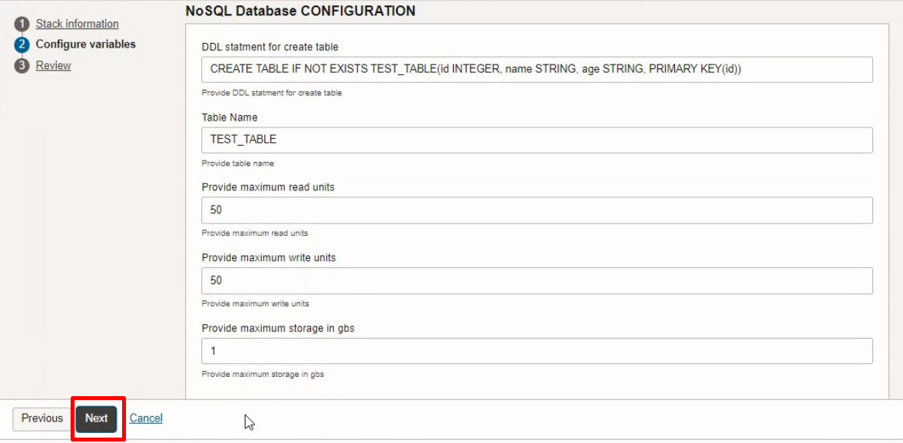
Click “NEXT”
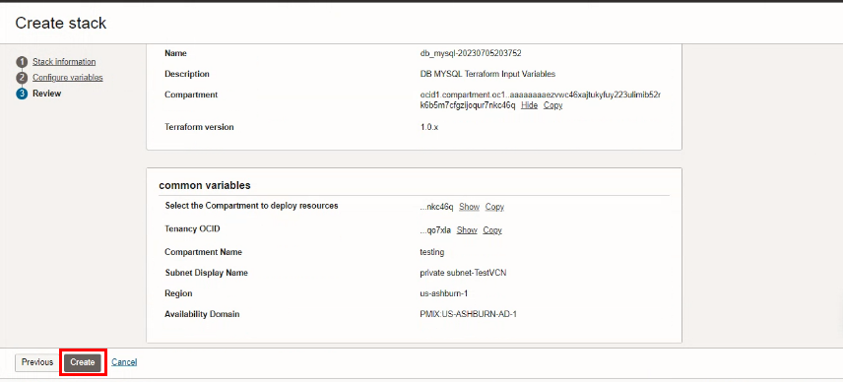
Click “CREATE”

Plan the Job

Click the “Plan”
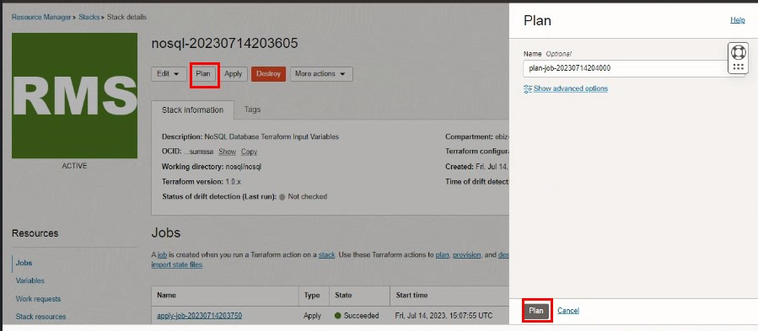

Verify the Plan is successful.

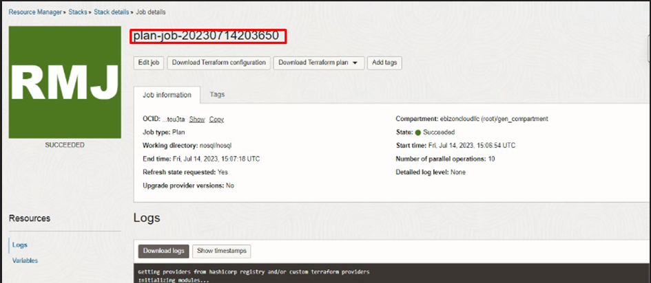

- Apply the Job

Once the “plan” is success, now click “Apply”

Verify the Apply is successful.

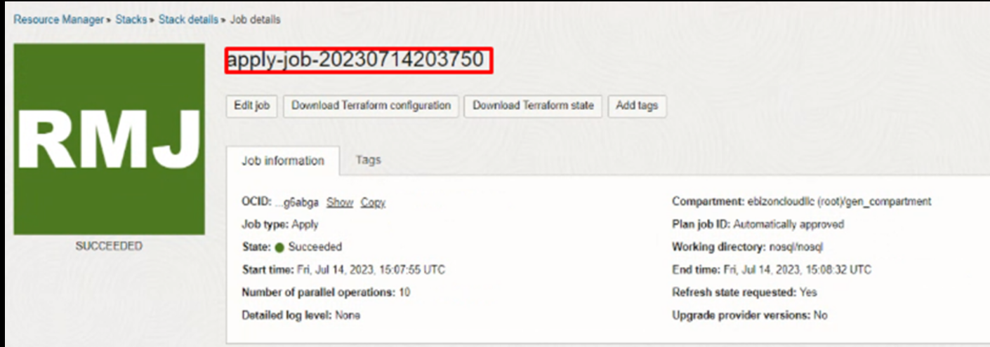

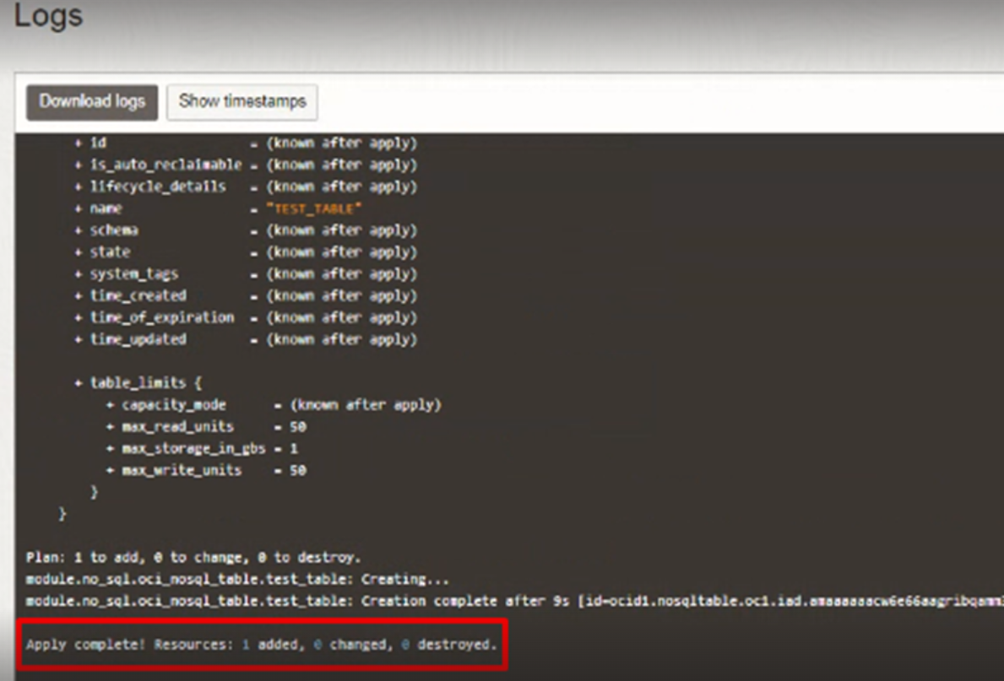

Verify in the Console

Go to OCI Console Database Oracle NoSQL Database Tables

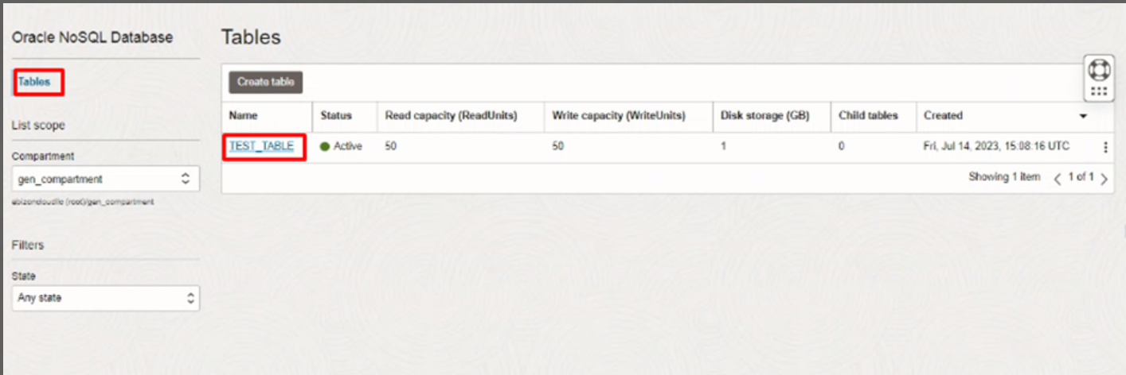

Go to OCI Console Database Oracle NoSQL Database Tables

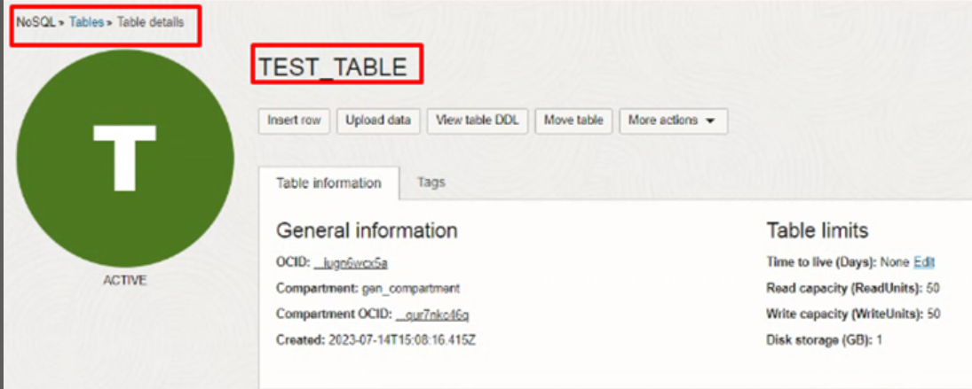

Destroy the stack

Create a destroy job in Resource Manager to release resources associated with a stack and clean up the tenancy. Once destroyed data cannot be recovered from resources.

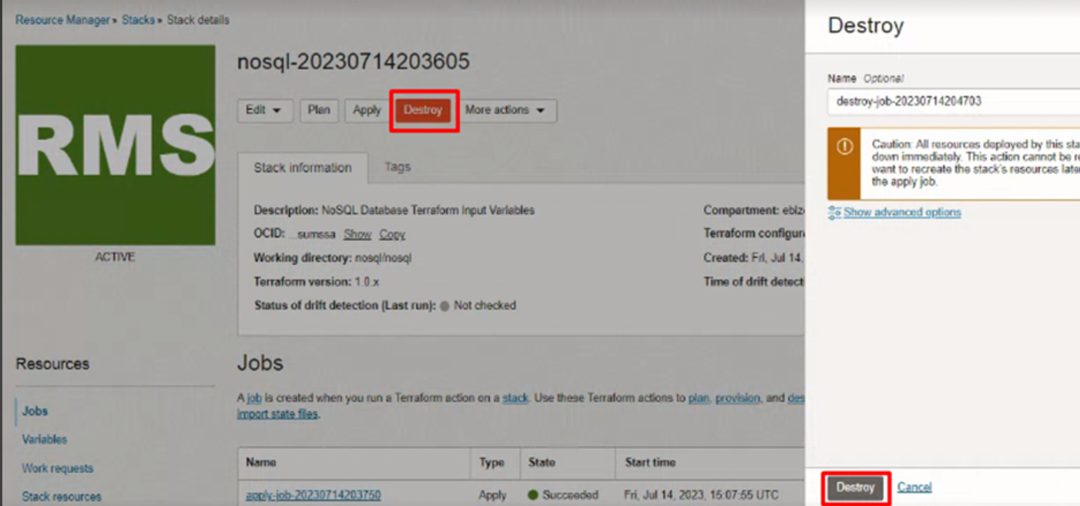

#END#

